8.3-20

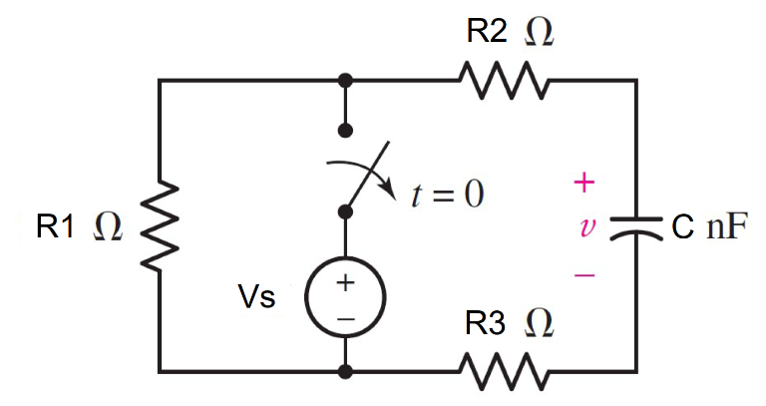

Given R1= 200Ω, R2= 100Ω, R3= 150Ω,

C = 2nF, Vs = 4V

Find

Variables (สำหรับเขียนโค้ดเพื่อหาคำตอบ)

Random variables

r1 = {100:500:100};

r2 = {100:500:50};

r3 = {100:500:50};

c= {1e-9:5e-9:1e-9};

vs = {1:10:1};

time = {1:5};

**Global variables**

#vs =4; r1 = 200; r2=100; r3=150;

c = 2*e^-9;

#t≥0

v0n=vs;

req =r1+r2+r3;

tau =c*req;

vt = v0n*exp^(-time);

Part (กรอกคำตอบ)

**Answer**

1. v(0+) = v0n = 4 V
2. τ =tau= **900x10-9** s.
3. v(t) = v0n*exp^(-t/tau) = 4*exp^(-t/900x10-9) V
4. v(time*τ*) = vt= 1.47152 V. *# time =1*

8.3-21

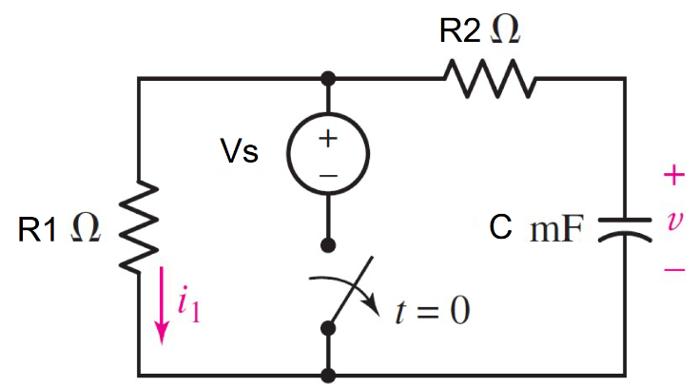

Given R1= 12Ω, R2= 9Ω, C = 50mF, Vs = 8V

Find

Variables (สำหรับเขียนโค้ดเพื่อหาคำตอบ)

Random variables

r1 = {100:500:100};

r2 = {100:500:50};

c= {10e-3:50e-3:10e-3};

vs = {1:10:1};

time = {1:5};

**Global variables**

#vs =4; r1 = 200; r2=100; r3=150;

c = 2*e^-9;

v0n=vs;

req =r1+r2;

tau =c*req;

vr1p = (r1/(r1+r2))*v0n;

ir1p= vr1p /r1;

i1 = ir1p*exp^(-time);

pr1=i1*i1*r1;

Part (กรอกคำตอบ)

1. v(0+) = v0n = 8 V
2. τ =tau= **1.05** s.
3. i1(t) =ir1p*exp(-t/tau) =**0.380952*exp^(-t/1.05) A**
4. Pr1(time*τ*) = pr1=3.928 w *# time =1*

8.3-22

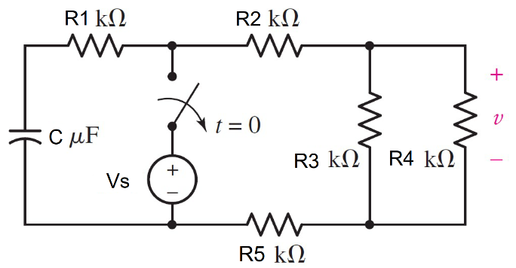

Given R1= 20kΩ, R2= 3kΩ, R3= 5kΩ, R4= 1kΩ,   
R5= 10kΩ, C = 5µ F, Vs = 12V

Find

Variables (สำหรับเขียนโค้ดเพื่อหาคำตอบ)

Random variables

r1 = {1000:20000:1000};

r2 = {1000:5000:1000};

r3 = {1000:5000:1000};

r4 = {100:1000:100};

r5 = {1000:10000:1000};

c= {1e-6:10e-6:1e-6};

vs = {1:20:2};

time = {1:5};

**Global variables**

#vs =12; r1 = 20000; r2=3000; r3=5000;

r4=1000; r5=10000; c = 5*e^-6;

req =(r4*r5/r4+r5)+r1+r2+r3;

tau =c*req ;

vc0=vs;

i0p = vc0/req;

v0p=i0p* (r3*r4/r3+r4);

vct= v0p*exp(-time);

wc=0.5*c*vct*vct;

Part (กรอกคำตอบ)

1. vc(0+)=vc0= 12 V.
2. τ =tau= 0.169 s
3. v(t) = v0p*exp^(-t/tau) =**0.2955*exp^(-t/0.169) V.**
4. v(time*τ*) = vct = 0.1087 V.
5. Wc(time*τ*) = wc=2.954 x10-8 J #power at C*# time =1*

8.3-23

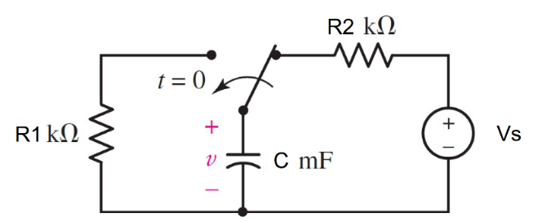

Given R1= 82kΩ, R2= 21kΩ, C = 12mF,

Vs = 20V

Find

Variables (สำหรับเขียนโค้ดเพื่อหาคำตอบ)

Random variables

r1 = {80000:100000:1000};

r2 = {10000:30000:1000};

c= {1e-3:20e-3:1e-3};

vs = {1:20:2};

time = {1:5};

**Global variables**

#vs =20; r1 = 82000; r2=21000;

c = 12*e^-3;

v0n=vs;

v0p=v0n

req =r1;

tau =c*req ;

vt= v0p*exp(-time);

wc=0.5*c*vt*vt;

Part (กรอกคำตอบ)

1. vc(0+)=v0p= 20 V.
2. τ =tau= 984 s
3. v(t) = v0p*exp^(-t/tau) =**20*exp^(-t/984) V.**
4. v(time*τ*) = vct = 7.3575 V.
5. Wc(time*τ*) = wc=0.1353 x10-3 J #power at C *# time =1*

8.3-24

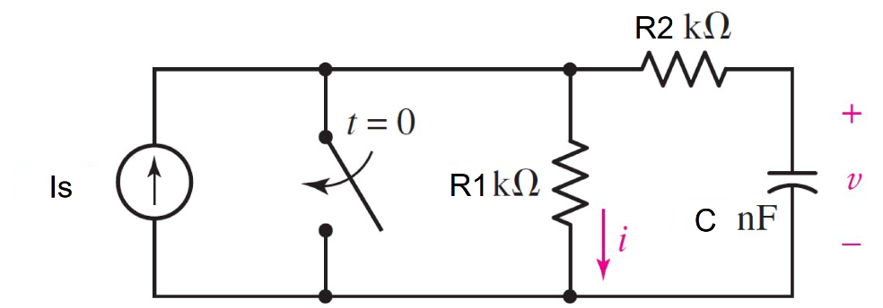

Given R1= 10kΩ, R2= 10kΩ, C = 150nF,

Is = 2mA

Find

Variables (สำหรับเขียนโค้ดเพื่อหาคำตอบ)

Random variables

r1 = {1000:10000:1000}

r2 = {1000:10000:1000}

c= {50e-9:200e-9:50e-9}

is = {1e-3:5e-3:1e-1}

**Global variables**

#is =0.002; r1 = 10000; r2=10000;

c = 150*e^-9;

#t<0

v0n=is*r1;

#t≥0

v0p=v0n;

req =r2;

tau =c*req ;

vt= v0p*exp(-time);

Part (กรอกคำตอบ)

1. vc(0+)=v0p= 20 V.
2. τ =tau= 1.5 ms
3. v(t) = v0p*exp^(-t/tau) =**20*exp^(-t/1.5x10-3) V.**
4. v(time*τ*) = vt = 7.3575 V. *# time =1*